Decoding Wolffia globosa Biomass Yield from Phytomicrobiome Signatures Using Interpretable Machine Learning Models
Anubrajo Ghosh & Prabrisha Basu
UG 2nd Year Semester-3
Postgraduate and Research Department of Microbiology,
St. Xavier's College (Autonomous), Kolkata
Abstract
Wolffia globosa, the world's smallest flowering plant, doubles its biomass in roughly two to three days and yields dry-weight protein content of 20–48% with a balanced essential amino acid profile, positioning it as a serious candidate crop for sustainable protein production in food, aquaculture feed, and circular bioeconomy applications. Commercial interest is no longer speculative: regulatory clearances and pilot-scale facilities already exist. Because the plant lacks roots and vascular reserves, however, visible symptoms of cultivation failure appear only after a culture has already begun to collapse. We propose the frond-associated phytomicrobiome as a leading, rather than lagging, indicator of culture health, and argue that as Wolffia globosa cultivation scales toward multi-tank commercial operations, this signal needs to be machine-readable rather than manually inspected. Using a literature-grounded synthetic cohort of 450 tank samples, we implement a pipeline that applies a centered log-ratio (CLR) transform to resolve the compositional structure of relative-abundance taxon data, trains a regularized XGBoost classifier to predict "biomass doubling competence," and applies TreeSHAP to attribute directional, per-taxon contributions to the prediction. The model achieves 78.9% accuracy, 84.4% recall, and an AUC-ROC of 0.91 at a recall-tuned threshold, with the nitrogen-fixing, cobalamin-provisioning symbiont Ensifer adhaerens emerging as the strongest predictor. We report this as a methodological proof of concept on simulated data and outline the path to validation on real amplicon-sequencing data.
Keywords: Wolffia globosa, phytomicrobiome, Aitchison simplex, centered log-ratio, XGBoost, TreeSHAP, biomass optimization
1. Introduction
1.1 Wolffia globosa in production
Wolffia globosa is the fastest-doubling flowering plant known, propagating vegetatively without seeds, roots, or a vascular system, and reaching population doubling in as little as two to three days under favourable conditions. Its dried biomass carries protein content of 20–48% by dry weight with a balanced amino acid profile, alongside dietary fibre, polyunsaturated fatty acids, and micronutrients — credentials that have already moved it past the laboratory-curiosity stage: the European Food Safety Authority issued a positive novel-food opinion for a patented Wolffia strain in 2021, and commercial cultivation facilities and duckweed-derived protein products have since reached pilot and early commercial scale. Because it requires no soil and minimal land area and grows efficiently in nutrient-rich water, including treated wastewater, it is increasingly proposed as a feed substitute for fishmeal in aquaculture and as a component of closed-loop, space-agriculture-style production systems.
1.2 The problems that come with it
This same minimalism is also the source of its central production problem. Wolffia globosa has no root system and no vascular reserve to buffer stress, so the plant cannot signal decline the way a rooted crop can through wilting or discoloured foliage; frond-density loss and chlorosis are late-stage symptoms that appear only once a culture is already collapsing. Traditional open, static-water cultivation is documented to suffer from hygiene concerns, inconsistent biomass yield, and susceptibility to environmental fluctuation, and even controlled, LED-lit tank systems are reported to develop patchy growth and visible fungal, mould, or filamentous-algae contamination that must be manually identified and chemically treated. This is not unique to Wolffia globosa: monoculture cultivation of related aquatic biomass crops such as microalgae is broadly documented to be vulnerable to contamination by yeasts, fungi, bacteria, and competing algal species, which can drive low productivity, culture collapse, and degraded biomass quality before an operator notice anything is wrong. Compounding the problem, dosing a stagnant or declining Wolffia globosa culture with additional chemical fertiliser to try to rescue it risks triggering exactly this kind of algal contamination, so symptoms cannot simply be treated once they become visible. Reviews of the field consistently list variability in nutrient composition, limited large-scale cultivation data, and uncertain economic feasibility at industrial scale as the key remaining barriers to commercial adoption, despite the plant's strong underlying biology. Current quality control in regulator-approved facilities relies on Good Manufacturing Practice and HACCP-style protocols built around physical containment and water chemistry, not on any direct read of the microbial community driving growth.
1.3 Why machine learning, and why now
This is the gap we target. We hypothesize that the frond-associated phytomicrobiome is a more informative, earlier signal of culture trajectory than either visual inspection or water chemistry — but only if it can be read automatically and at the scale a commercial operation demands: a facility running dozens of parallel tanks cannot rely on a technician's eye on each one, the way a single research tank can. Amplicon-sequencing taxon data, however, are not simple inputs for standard monitoring software. They are high-dimensional and sparse relative to sample size, and their relative-abundance values are compositional, constrained to sum to a fixed total, which induces spurious negative correlations under ordinary statistics. Univariate tests, moreover, cannot capture the non-linear, syntrophic interactions between beneficial and opportunistic taxa that plausibly govern whether a tank is heading toward the kind of contamination-driven collapse described above. This combination — a scaling industry, a lagging visual signal, a chemical-rescue trap, and a data structure unsuited to classical statistics — is precisely the setting in which an interpretable, tabular-data machine learning model earns its place over both manual inspection and an unexplainable black-box model: it must run non-destructively across many tanks in parallel, and its output must be explainable enough that a grower or regulator can act on it and trust it.

2. Related Work
Aitchison (1982) formalized the compositional-data problem; his log-ratio transformations remain the standard route for projecting simplex-constrained data onto Euclidean space before modelling. In the human gut microbiome literature, gradient-boosted trees paired with Shapley-value explainability have been applied at scale to metagenome-wide association data, notably in the lineage following Qin et al.'s (2012) type-2-diabetes gut microbiome study, establishing microbial dysbiosis as an ML-tractable signal ahead of conventional clinical markers. We transplant this general framework — not the disease application — to a plant-cultivation context. On the Wolffia side, Saimee et al. (2025) identified Beijerinckiaceae, Rhizobiaceae, and Sphingomonadaceae as core taxa shaping W. globosa growth across diverse bacterial communities, while Kettongruang et al. (2026) screened 116 duckweed-associated isolates and reported biomass increases of up to 77.75%. Toyama et al. (2022) showed Ensifer sp. SP4 directly enhances nitrogen metabolism and photosynthesis in Spirodela polyrhiza, and Ensifer adhaerens specifically is an industrially exploited cobalamin producer (Zhao et al., 2019) — the rationale for its role in this study.
3. Methodology
3.1 Synthetic cohort design
Lacking an in-house sequenced dataset, we constructed a literature-grounded synthetic cohort of 450 simulated tank samples, each recording twelve taxa across three functional categories: five plant-growth-promoting bacteria (Ensifer adhaerens, Bacillus megaterium, Pseudomonas fluorescens, Azospirillum brasilense, Rhizobium sp.), five opportunistic or fouling-associated taxa (Aeromonas hydrophila, Pseudomonas aeruginosa, Flavobacterium columnare, Chryseobacterium sp., Elizabethkingia sp.), and two functionally neutral background taxa (Sphingomonas sp., Microbacterium sp.) included as a negative control on pipeline specificity. Each sample also carries water temperature, pH, ammonium-nitrogen, and a Shannon-style diversity index. The binary target, Biomass_Status, denotes high versus low doubling competence. Abundances were drawn from class-conditional normal distributions with a 15% outlier rate, so classes are not trivially separable. Ensifer adhaerens was deliberately given the tightest, most separated distribution among beneficial taxa, reflecting its documented dual role as nitrogen-fixer and cobalamin source — a design choice for this proof of concept, not an empirical finding.
The three cultivation covariates were parameterized to reflect literature-reported operating ranges for aerated Wolffia globosa tank systems: water temperature centred near 27°C, pH held closer to neutral for the high-competence class and drifting mildly alkaline for the low-competence class, and ammonium-nitrogen bracketing the roughly 8–14 mg/L band reported for nitrate-fed suspended-growth systems, with low-competence samples biased toward the higher, more ammonia-stressed end. The Shannon-style diversity index was parameterized in the opposite direction to what is typically reported in gut dysbiosis: higher, not lower, diversity was assigned to the high-competence class, on the working assumption that a richer beneficial consortium outcompetes opportunists more effectively than a community dominated by one or two taxa. This is a deliberate point of contrast with the human-microbiome literature this pipeline borrows its statistical machinery from, and is flagged here rather than left implicit.
Pairwise relationships among the raw, pre-CLR taxa and cultivation covariates are shown in Fig. 1.
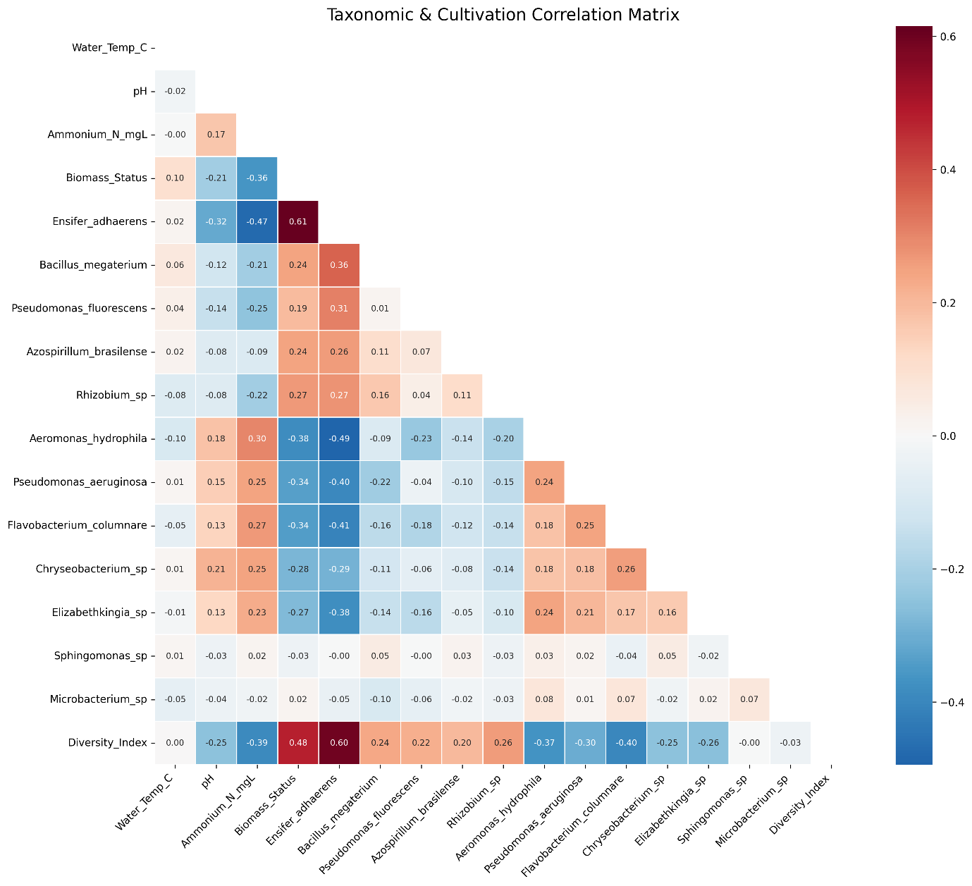
Figure 1. Pairwise correlation matrix of the synthetic phytomicrobiome and cultivation cohort (n = 450), prior to CLR transformation.
3.2 Compositional transformation
Raw taxon values were converted to centered log-ratio (CLR) coordinates. For a sample's taxon vector x, with pseudo count ε: $CLR\left(xᵢ\right)=log\left(xᵢ+ε\right)-mean₁..D\left[log\left(x+ε\right)\right]$
This projects the constrained simplex onto unconstrained Euclidean coordinates suitable for standard multivariate modelling (Aitchison, 1982).
3.3 Model and explainability
CLR-transformed taxa were concatenated with cultivation covariates into a 16-dimensional feature matrix, split 80/20 (stratified), and used to train an XGBoost classifier (Chen & Guestrin, 2016; 150 estimators, max depth 4, learning rate 0.08) with both L1 (α = 0.5) and L2 (λ = 1.0) regularization — chosen to manage the collinearity CLR introduces, since every transformed feature shares a common geometric-mean term. A decision threshold of 0.40 traded precision for recall, on the reasoning that in cultivation monitoring a missed decline is costlier than a false alarm. Predictions were attributed to individual features using TreeSHAP (Lundberg & Lee, 2017), which derives Shapley values quantifying each taxon's directional contribution, in contrast to gain-based importance, which only ranks aggregate split quality.
4. Results
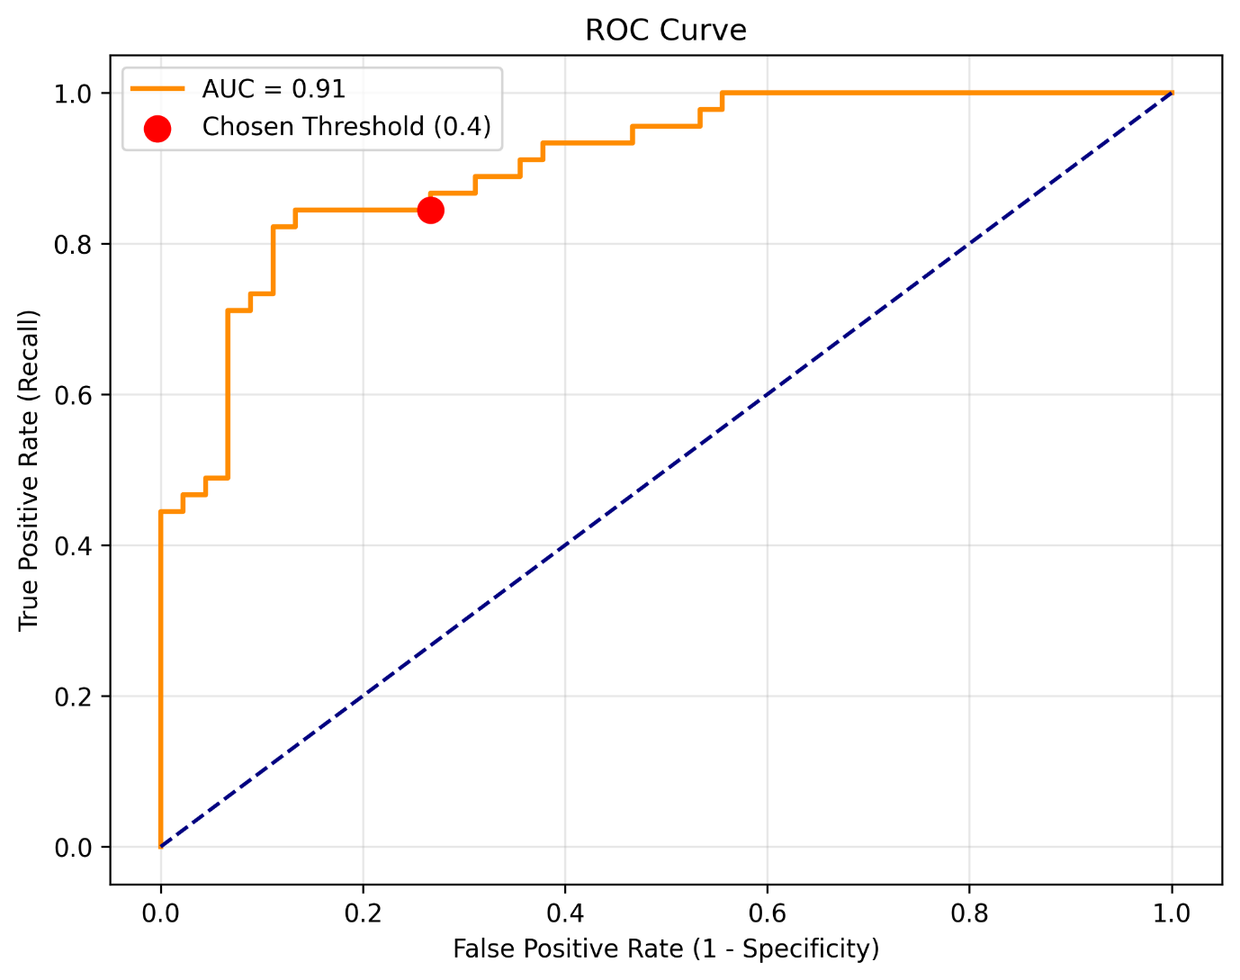
On the held-out test set (n = 90), the tuned classifier achieved 78.9% accuracy, 84.4% recall, and 76.0% precision, with AUC-ROC = 0.91 (Fig. 2).
Figure 2. ROC curve for the XGBoost classifier on the held-out test set (AUC = 0.91), with the recall-tuned 0.40 threshold marked.
At the chosen 0.40 threshold, the model produced the class-wise error breakdown shown in Fig. 3. Of the 45 low-competence test tanks, 33 were correctly flagged and 12 were incorrectly cleared as healthy (false positives); of the 45 high-competence tanks, 38 were correctly identified against 7 missed declines (false negatives). This asymmetry is intentional: the 0.40 threshold favours catching a genuine decline over avoiding an occasional false alarm, consistent with the recall-first framing in Section 3.3.
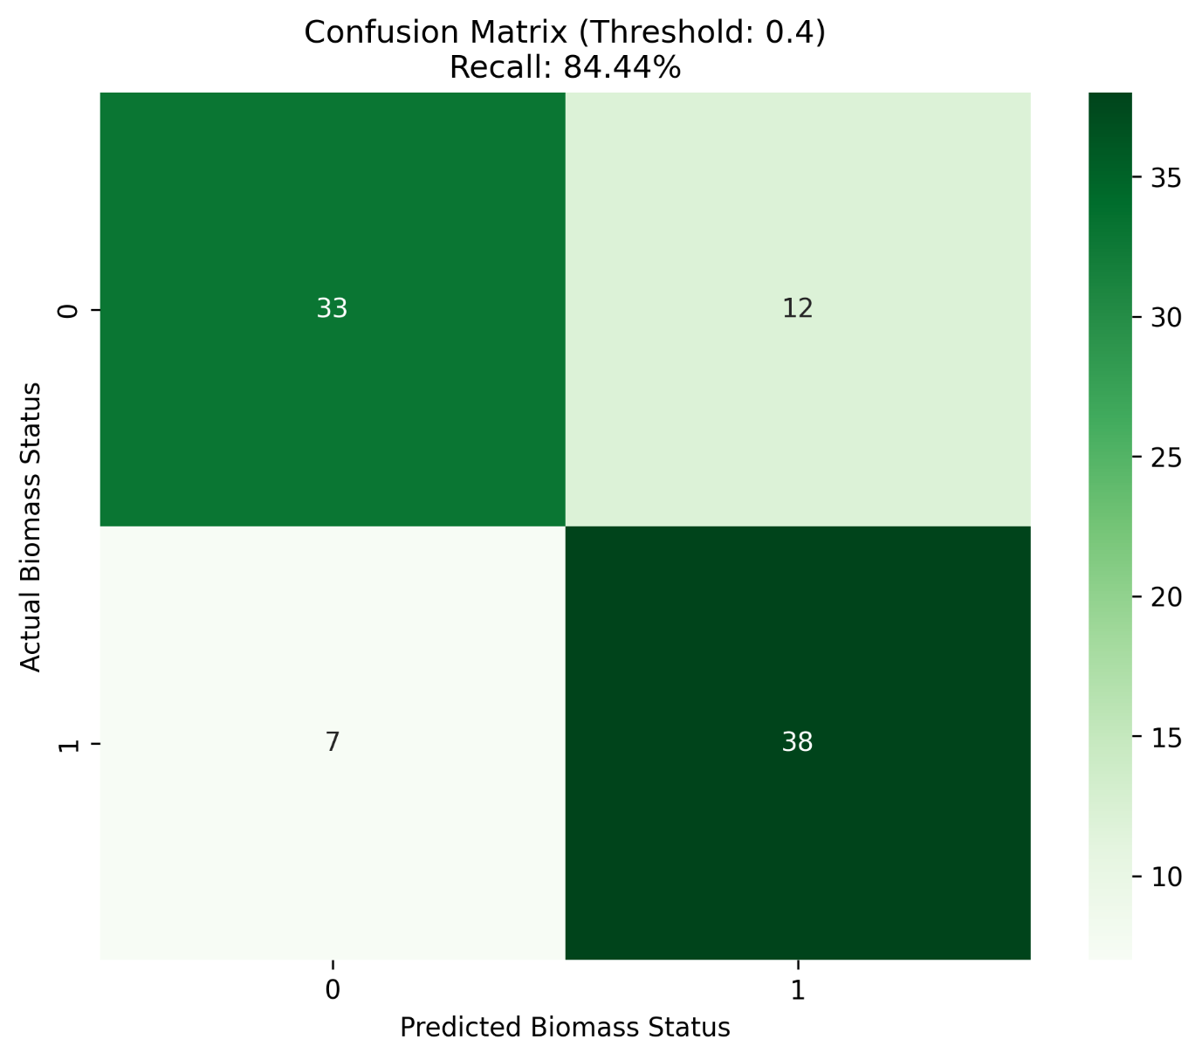
Figure 3. Confusion matrix at the 0.40 decision threshold (n = 90 test samples).
Both the gain-based importance ranking (Fig. 4) and the SHAP summary (Fig. 5) identified CLR-transformed Ensifer adhaerens abundance as the strongest predictor by a wide margin, consistent with its documented function as a nitrogen-fixing, cobalamin-provisioning duckweed symbiont (Toyama et al., 2022; Zhao et al., 2019). Figure 4 ranks the sixteen features by XGBoost's gain-based importance — how much each split on that feature improved the model, summed across all trees — giving a single, model-global measure of usefulness with no directionality attached. Figure 5 complements this with a per-sample view: each dot is one test-set tank, its horizontal position is that feature's Shapley contribution to that specific prediction, and its colour is the feature's own value (CLR-transformed abundance, high in pink, low in blue), so the two plots together show not just which taxa matter, but which direction — and how consistently — each one pushes the prediction.
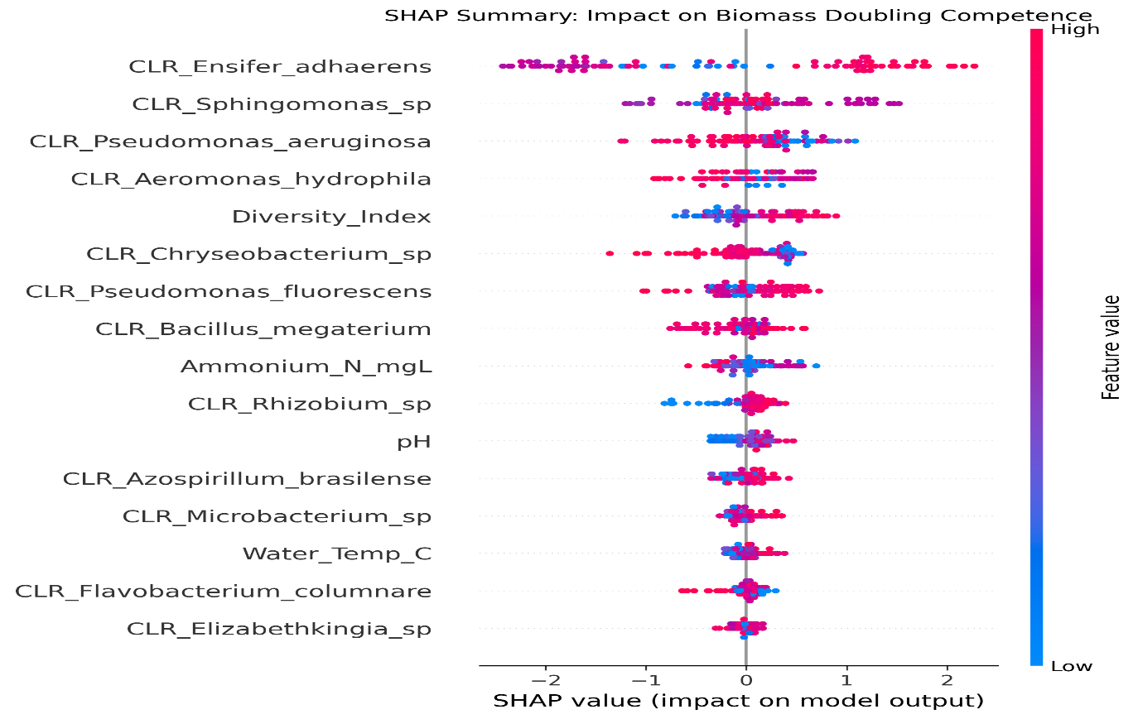
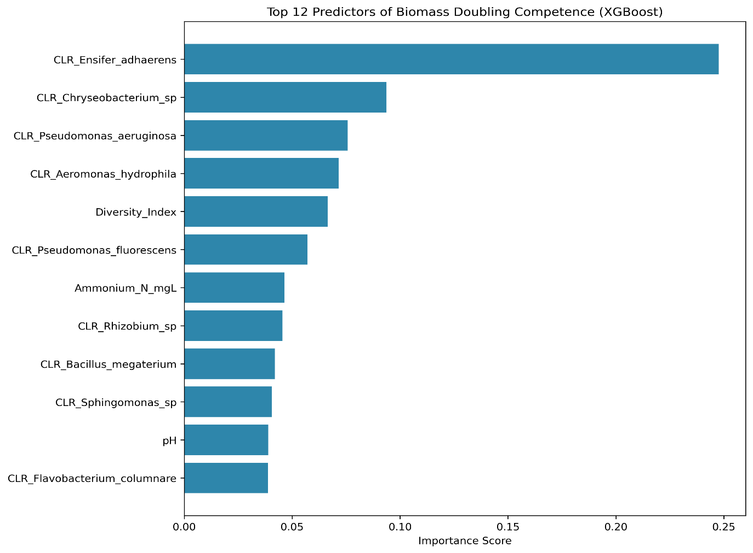
Figure 4. Top 12 predictors of biomass doubling competence, ranked by XGBoost gain-based importance.
Figure 5. TreeSHAP summary plot: per-sample directional contribution of each feature to the predicted biomass status.
The opportunistic taxa Chryseobacterium sp., Pseudomonas aeruginosa, and Aeromonas hydrophila formed the next most informative group in both figures, each with the expected sign: higher abundance pushed predictions toward low competence. One artifact is worth reporting rather than concealing: in the SHAP beeswarm specifically (Fig. 5), the functionally neutral Sphingomonas sp. ranked unexpectedly high — a ranking not mirrored in the gain-based importance of Fig. 4. This is not a hidden biological signal but a direct consequence of CLR's shared geometric-mean denominator, which entangles every taxon's transformed value with the informative ones — a known property of log-ratio analysis, and a reminder that SHAP rankings on CLR features should be cross-checked against gain-based importance (compare Fig. 4 and Fig. 5) rather than read as raw biological evidence on their own.
5. Discussion
These results demonstrate that the proposed pipeline can recover a designed signal from compositional microbiome data and surface a biologically interpretable, literature-consistent sentinel taxon rather than an opaque score — but the dataset is synthetic and effect sizes were author-assigned rather than measured. The real evidence base — that PGPB inoculation substantially increases duckweed biomass (Kettongruang et al., 2026; Sucunthowong et al., 2026) and that Ensifer species specifically promote duckweed growth (Toyama et al., 2022) — supports the plausibility of the taxa and effects chosen here, but plausibility is not validation. Given the production problems outlined above — contamination-driven collapse, lagging visual symptoms, and the chemical-rescue trap — the practical value of this work is as a pre-registered analytical framework: once real 16S amplicon data from replicate, industrial-scale Wolffia tanks become available, this same pipeline — including its known CLR artifact (Fig. 5) and recall-tuned threshold (Fig. 2, Fig. 3) — can be re-run as a genuine, non-destructive early-warning tool, rather than requiring a new methodology at the point a commercial operator actually needs it.
6. Conclusion
We present an interpretable machine learning pipeline — CLR transformation, regularized XGBoost, and TreeSHAP attribution — for predicting Wolffia globosa biomass doubling competence from phytomicrobiome composition, motivated directly by the gap between Wolffia's fast-scaling commercial production and the slow, visual, chemistry-only monitoring tools that production currently relies on. Validated on a literature-grounded synthetic cohort of 450 samples (78.9% accuracy, AUC-ROC 0.91), the framework correctly surfaces Ensifer adhaerens as the dominant predictive taxon, consistent with independently published evidence for its role in duckweed growth promotion. It is offered as a pre-validated analytical scaffold for future work on real amplicon-sequencing data, toward non-chemical, microbiome-informed early-warning systems for circular aquaculture at commercial scale.
Code and Data Availability
The full data-generation and modelling pipeline, including all figures reproduced in this paper (Figs. 1–5), is hosted on GitHub and can be accessed through this link: https://github.com/Anubrajo-Ghosh/MTMA-Beacon-Magazine-Code.git.
References
- Aitchison, J. (1982). The statistical analysis of compositional data. Journal of the Royal Statistical Society: Series B (Methodological), 44(2), 139–160. https://doi.org/10.1111/j.2517-6161.1982.tb01195.x
- Chen, T., & Guestrin, C. (2016). XGBoost: A scalable tree boosting system. In Proceedings of the 22nd ACM SIGKDD International Conference on Knowledge Discovery and Data Mining (pp. 785–794). ACM. https://doi.org/10.1145/2939672.2939785
- EFSA Panel on Nutrition, Novel Foods and Food Allergens (NDA). (2021). Safety of Wolffia globosa powder as a Novel food pursuant to Regulation (EU) 2015/2283. EFSA Journal, 19(12), e06938. https://doi.org/10.2903/j.efsa.2021.6938
- Kettongruang, P., Saimee, Y., Kuwai, K., Ishizawa, H., Inoue, D., Thamchaipenet, A., & Ike, M. (2026). Diversity and plant growth-promoting potential of duckweed-associated bacteria on Wolffia globosa biomass production and nutritional quality. Environmental Microbiology Reports, 18(1), e70312. https://doi.org/10.1111/1758-2229.70312
- Lundberg, S. M., & Lee, S.-I. (2017). A unified approach to interpreting model predictions. In Advances in Neural Information Processing Systems (Vol. 30, pp. 4765–4774). Curran Associates, Inc. https://doi.org/10.48550/arXiv.1705.07874
- Naseema Rasheed, R., Pourbakhtiar, A., Mehdizadeh Allaf, M., Baharlooeian, M., Rafiei, N., Alishah Aratboni, H., Morones-Ramirez, J. R., & Winck, F. V. (2023). Microalgal co-cultivation — recent methods, trends in omic-studies, applications, and future challenges. Frontiers in Bioengineering and Biotechnology, 11, 1193424. https://doi.org/10.3389/fbioe.2023.1193424
- Qin, J., Li, Y., Cai, Z., Li, S., Zhu, J., Zhang, F., Liang, S., Zhang, W., Guan, Y., Shen, D., Peng, Y., Zhang, D., Zhou, Z., Zhang, J., Li, X., Li, W., Li, N., He, C., Li, J., … Wang, J. (2012). A metagenome-wide association study of gut microbiota in type 2 diabetes. Nature, 490(7418), 55–60. https://doi.org/10.1038/nature11450
- Rajesh, S. D., Yadav, N. K., Angom, J., Kumari, N., Campal, E. I., Kalaiselvan, P., Kumar, P., Kakakhel, M. A., & Patel, A. B. (2026). Wolffia globosa as a multifunctional sustainable bioresource: Applications in aquaculture nutrition, functional foods, and circular bioeconomy. Aquaculture Journal, 6(3), 38. https://doi.org/10.3390/aquacj6030038
- Saimee, Y., Kuwai, K., Ishizawa, H., Inoue, D., Thamchaipenet, A., & Ike, M. (2025). Structural and functional properties of bacterial communities associated with rootless duckweed (Wolffia globosa) and their effect on the Wolffia growth. Environmental Microbiome, 20(1), 12. https://doi.org/10.1186/s40793-025-00759-6
- Sucunthowong, K., Motlagh, S. R., Plengsakul, J., Powtongsook, S., & Nootong, K. (2026). Enhancing Wolffia globosa cultivation: Feasibility of aerated suspended-growth systems as alternative cultivating option and the influence of abiotic factors on biomass production, CO₂ capture, and biochemical composition. Process Biochemistry, 160, 31–40. https://doi.org/10.1016/j.procbio.2025.11.020
- Toyama, T., Mori, K., Tanaka, Y., Ike, M., & Morikawa, M. (2022). Growth promotion of giant duckweed Spirodela polyrhiza (Lemnaceae) by Ensifer sp. SP4 through enhancement of nitrogen metabolism and photosynthesis. Molecular Plant-Microbe Interactions, 35(1), 28–38. https://doi.org/10.1094/MPMI-06-21-0157-R
- Zhao, T., Cheng, K., Cao, Y. H., Ouwehand, A. C., Jiao, C. F., & Yao, S. (2019). Identification and antibiotic resistance assessment of Ensifer adhaerens YX1, a vitamin B12-producing strain used as a food and feed additive. Journal of Food Science, 84(10), 2925–2931. https://doi.org/10.1111/1750-3841.14804
A Note on the Alignment of the Article to the Theme of Beacon Volume-XIII
Through The Primal Lens: Underneath the biology, this paper is really a study in returning to fundamentals. Long before either Wolffia globosa or XGBoost existed to a data scientist, two much older ideas were quietly waiting to be useful here. In 1982, the statistician John Aitchison pointed out that percentages lie to you — that data constrained to sum to a fixed total distorts ordinary correlation — and proposed going back to raw log-ratios to recover what's actually true underneath. And in 1953, the mathematician Lloyd Shapley solved a problem in cooperative game theory — how to fairly split a payoff among players who only win by working together — decades before anyone thought to use it to ask a decision tree which bacterium deserves credit for a healthy tank. Neither idea was built for this problem. Both turned out to be exactly what it needed. That, perhaps, is the primal lens: not looking for what's new, but for what was true all along, waiting for a reason to matter again.

